
HOW TO COMPLETE THE STANDARD SOP TEMPLATE

The intention of this document is to provide detailed guidance on how to complete the WHO/GMG standard SOP template.
Contents
I. SOP Templates 1
II. SOP Naming, Front Page, Headers 1
i. SOP Naming 1
ii. SOP Front Page 2
iii. SOP Headers 2
III. Introduction 2
i. Overview / Description 3
ii. General Guidance / Business Rules 3
iii. Reference Material 5
IV. Process Flow 6
V. Process Steps 7
VI. Key Risk & Compensating Controls 10

I. SOP Templates
Each GMG department has its own predetermined color scheme. SOP templates should therefore be chosen based on which department owns a respective process. The attachments below include SOP templates that should be used for each department.
For reference http://intranet.who.int/homes/gmg/docs/templates/
HRD | FNM | OSS | PRP | ITT | GSC

II. SOP Naming, Front Page, Headers

i. SOP Naming
The SOP naming consists of five elements (e.g. HR.SOP.XI.006 Confirmation of Appointment, FIN.SOP.II.001) as explained below.
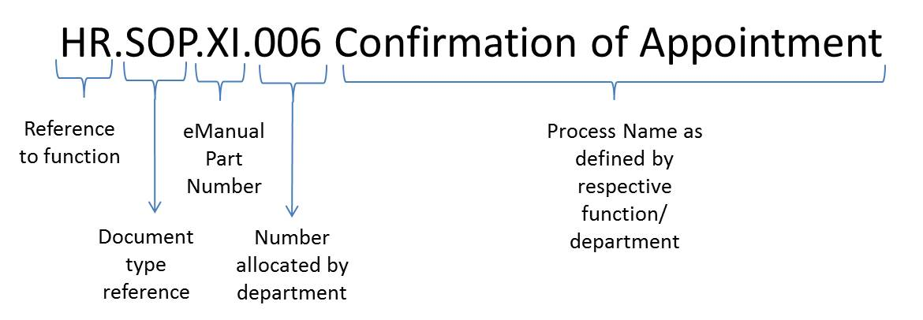
1. Reference to function | This should be an abbreviation for the respective function as follows:  HR for Human Resources  FIN for Finance  PRP for Planning, Resource, Coordination, and Performance Monitoring  PRT for Procurement  TRV for Travel  IT for Information Technology
2. Document type reference | This should always be “SOP” so that it is clear that the document is a standard operating procedure.
3. eManual Part Number | This roman number should indicate which section of the WHO eManual the SOP is related to. Please refer to http://emanual.who.int/Pages/eManualHome.aspx
4. Number allocated by department | This element should include 3 digits. In case of numbers below 100, use zeros as placeholders as shown in the example above. The numbers need to be determined by the departments themselves. The SOP coordinator for the respective department needs to ensure that the numbering within the department is consecutive. Should two SOPs be closely related, it is acceptable to add one letter at the end of the number (e.g. HR.SOP.III.011A Acting to a higher position without extra pay, HR.SOP.III.011B Acting to a higher position with extra pay) to indicate the close link.
5. Process Name as defined by respective department | This should include a brief title of the described process. It should be kept as brief as possible and should not exceed 10 words.

ii. SOP Front Page
The front page middle section should include 4 lines:
- the SOP Number
- the SOP Title
- the responsible Unit and department abbreviation
- abbreviation of the department name + “Standard Operating Procedure”
- Target Audience: either “All Staff” if dissemination is planned via eManual or “Back Office” for restricted use only

Examples:

The footer of the first page should include 2 lines: the department responsible for the SOP and “General Management”. An example is provided below:


iii. SOP Headers
The headers from page 2 onwards should include the same information as provided in the first two lines of the middle section of page one, namely the SOP number and the SOP name.
Examples:
 | 

III. Introduction
The introduction section of the SOP should include at least the following 3 sections: (1) overview/description, (2) general guidance/business rules, and (3) reference material. In addition, other sections may be added when deemed necessary (e.g. prerequisites).

i. Overview / Description
Explanation:
This section should include few sentences describing which process/aspects of a process the respective SOP covers.

Examples:
SOP | Overview/Description
Certification of Donor Agreements | This instruction provides guidance for the clearance and certification of donor agreements.
Separation on death of a staff member | This Standard Operating Procedure explains the process related to administrative actions to be completed upon receiving a notification of a staff members death.
PO based invoice processing | This Standard Operating Procedure provides guidance for the processing of invoices related to purchase orders by the Accounts Payable group.

ii. General Guidance / Business Rules
Explanation
This section should describe in simple words the overarching principles that govern the process to be described and provide other business rules, that due to their more general nature are not captured in the description of the detailed process steps. It should not be a “copy paste” of the WHO eManual. As part of the introduction, this subsection should be seen as providing the “big picture” or “setting the stage” for the SOP reader before entering into the details of the process flow and process steps.
Example 1:
SOP | General Guidance / Business Rules
Hospitality expenditure | - Hospitality expenses may be incurred for the entertainment of persons to further the interests of the Organization, particularly for priority programmes and activities. eManual section XII.10 provides full details on the allowable expenses, guests and limits (as a % of per diem) to be applied.  - Each biennium the Director-General will formally authorize hospitality limits to designated staff.  - In the Regional Offices, the BFO as the Certifying Officer for hospitality can authorize hospitality reimbursements to be paid locally through eImprest rather than through Accounts Payable. In these cases the country office needs to open an e Imprest purchase order (PO) in the name of the official to whom the Regional Director has allocated a hospitality allowance (Directors in the regional office, WR or head of office) and in the currency to be used for reimbursement/ payment.  - Each payment of hospitality expense must be accompanied by the attached hospitality form and cleared by the respective Certifying Officer (ACT at HQ and BFO in the Regional Offices).

Example 2:
SOP | General Guidance / Business Rules
PO based invoice processing | - The use of purchase orders (PO) in the purchase to payment process is very important as it allows the organization to better control its supplier relations and financial commitments to 3rd parties.  - Purchase Orders ensure that transactions are correctly approved within WHO before a financial commitment is entered into and that goods/services are delivered in accordance to the initial purchase agreement.  - Invoices from the following 3rd parties should be purchase order related:  - Suppliers of goods or services  - Service Contractors (APW, TSA, DFC)  - Travel Agents  - Shipping/Forwarding Agent  - All supplier invoices should include the reference to the PO number issued to them prior to commencement of work.  - Invoices from forwarding/shipping and travel agents must include a PO reference.  - Purchase order based invoices are processed by either 2 or 3 way matching depending on the type of purchase:
  Purchase orders for goods and services  (supplier invoices, proxy invoices) | Purchase orders for Travel & SSA
  ↓ | ↓
  3 Way Matching  (1. Invoice amount – 2. PO amount – 3. Actual receipt amount) | 2 Way Matching  (1. Invoice amount is matched to the PO amount)

iii. Reference Material
Explanation:
This section should include references to all related materials that determine policy, help staff to perform specific tasks or establish the link to related SOPs. The list of reference types can include, but is not restricted to the following: Staff Rules, WHO e-Manual, UPK, related forms, related SOPs. Of note, it is very important to include references to related SOPs. For example, HR SOPs describing staff entitlement processing should be cross referenced to the related SOPs in the Payroll unit documenting the payment processing of those entitlements.
Examples:
Home Leave | Separation on death of a staff member
Staff Rules  Staff Rule 640 - Home leave  Staff Rule 1010.3 - Resignation  Staff Rules 810 and 820 - Travel of Staff Member, spouse and children  WHO eManual  III.6.13 Home leave  III.8 Travel and Transportation : III.8.3 Home leave Travel III.8.7 Lump sums for travel  UPKs  Leave and Absence Management - Leave Types – 6.252 Home leave Review & Approve; 6.403 Home Leave Request  Travel Management - Travel Request Creation and Approval - Raise a Travel request - Statutory Travels  Related SOPs  HR.SOP.III.19B Home Leave | Staff Rules  710 Pension  720 Accident and illness insurance  730 Compensation for illness, injury or death attributable to service  770 Grant in case of death  870 Expenses on death  WHO e-Manual  III.10.20 Death of a Staff Member  III.20.ANNEX.10.B  III.8.9 Expenses on death  III.7.6 Grant in case of death  Related Forms  WHO90.6  WHO417  WHO418  WHO278  WHO96.2  WHO96.2(b)  WHO736  PENS E/2  Related SOPs  FIN.SOP.XII.PAY.004  FIN.SOP.XII.PAY.037

IV. Process Flow
Explanation
This section should include a Microsoft Visio diagram that depicts the end to end process. The following points should be observed:
- The flow chart should include a swim lane for every major contributor/actor in the process
- A flow chart element should be included for each major process step.
- A flowchart is a bird’s view on a specific process and should be easy to understand. It must therefore not include all detailed sub process steps listed in section 3 of the SOP
- Different activity types should be included using the appropriate basic flow chart shape as shown below.
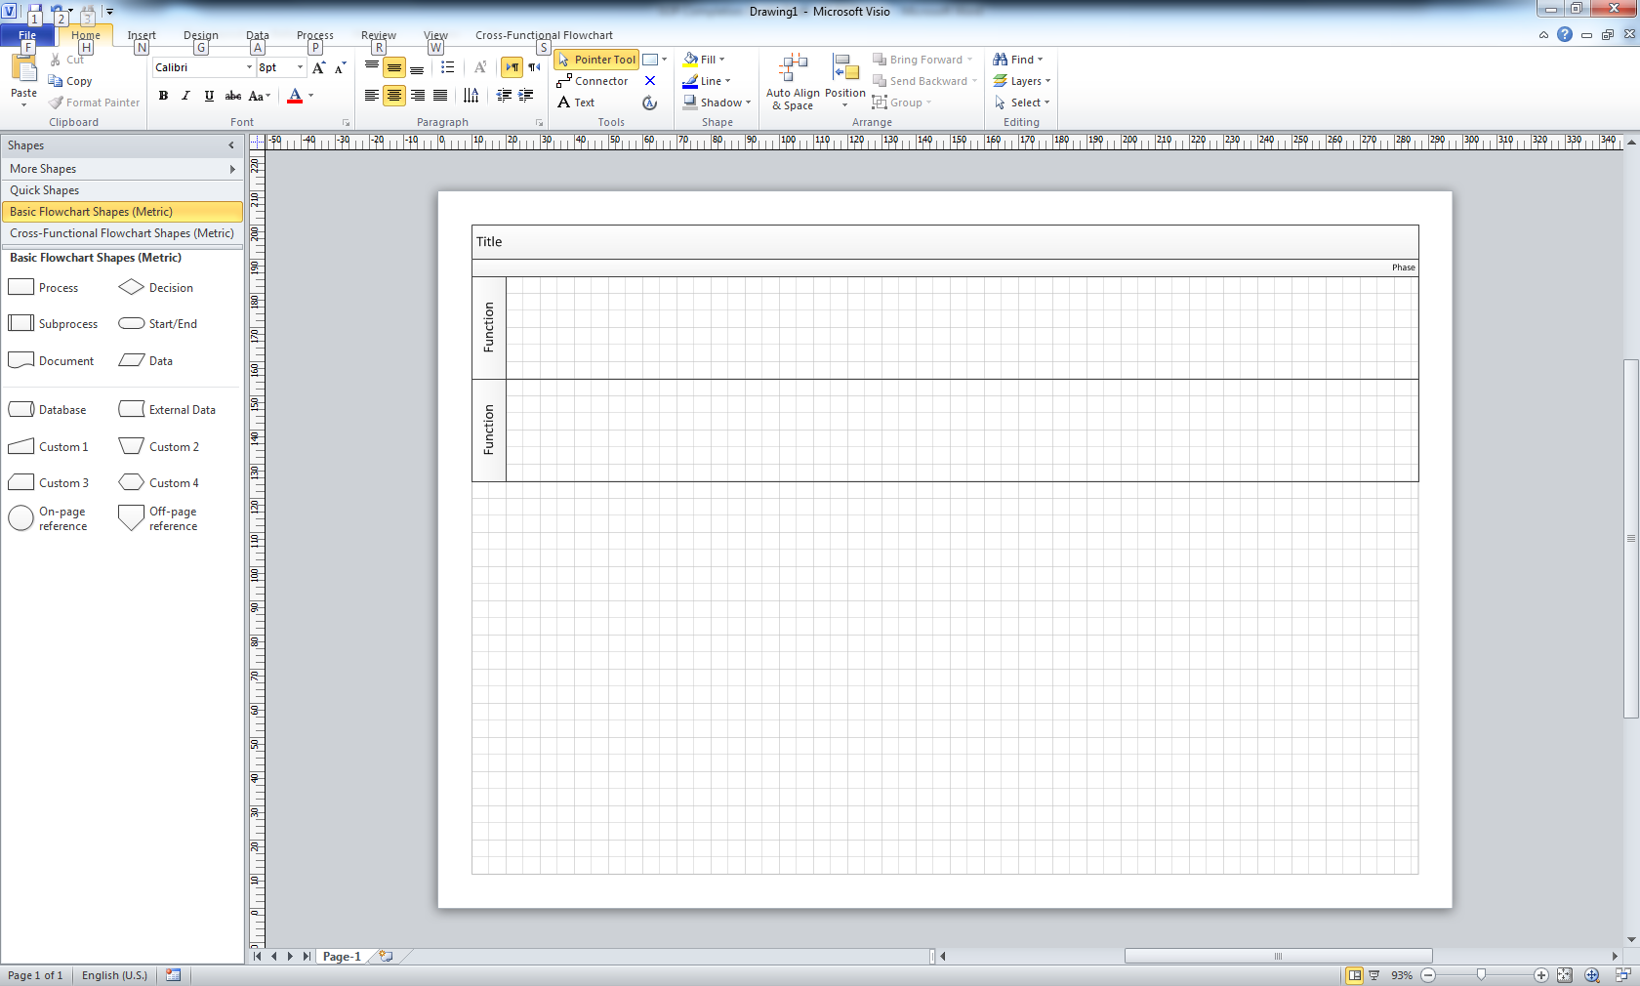
- The flow chart elements should be numbered in order to be able to better follow the process flow. The numbers should agree with the process steps numbers used in section 3
- A red hexagon with a C in the middle () should indicate visually where key controls in the depicted process take place
- Visio default colors (for MS Visio 2010 this is light grey, for MS Visio 2003 light blue) should be used for all swimlanes and boxes, expect for the start and end points which should be light blue and control points which should be red.
- Users can modify the size of boxes depending on the amount of text to be inserted, but text should not be formatted in bold or italic.

Example 1:
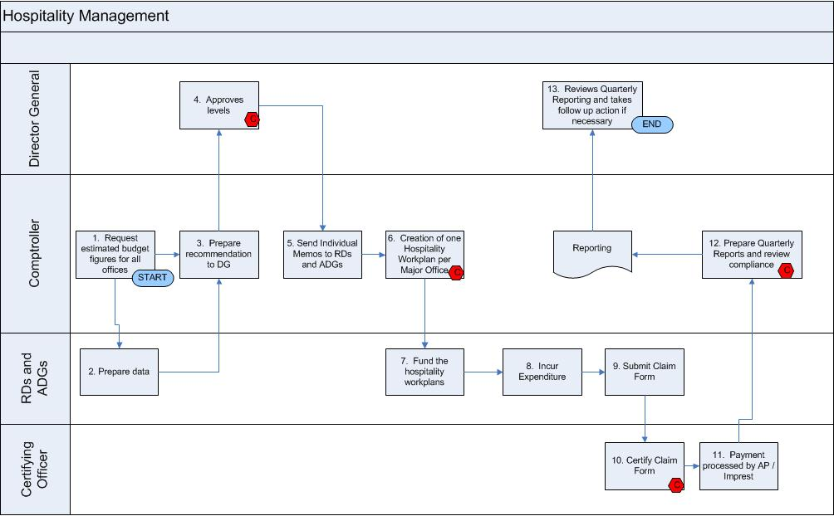
Example 2:
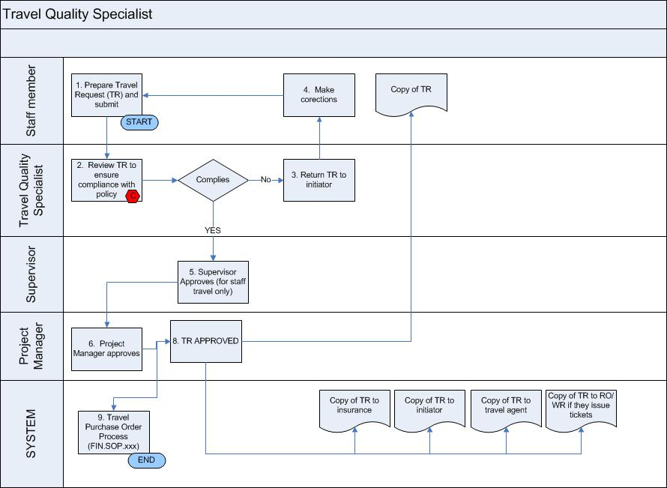

V. Process Steps
Explanation
This section should be composed of a table describing in chronological order the related process steps. Of note, sub process steps can be inserted (e.g. 5.1, 5.2) for more detailed instructions on how to perform a specific task. However, this is not a must. If preferred, job aid instructions can also be outlined at the end of the main table. As SOPs are meant to be comprehensive documents covering a specific process, it should be avoided to keep job aid type of information in separate documents.
The table listing the process step descriptions should include the following 5 columns:
Step | Control | Type | Process | Role / Responsibility

Step | - number each major process step from 1 onwards  - sub-process steps (e.g. 5.1, 5.2, etc.) can be included for more detailed explanations or job aid instructions. Such information, however, can also be included at the end of the table as a separate section of the SOP
Control | - If a certain process step involves a control that compensates one of the key risks outlined in section 4 (Key Risks & Compensating Controls) of the SOP, a “C” should be included in this field.  - Cs should only be allocated to process steps, not sub process steps.
Type | - The purpose of this field is to classify how the respective process step is performed. Examples of process type include:  - Offline (if no system is used to perform the process step)  - GSM  - RMS  - eSLA
Process | - The purpose of this field is to describe the process step.
Role, Responsibility | - In this field, the writer needs to indicate who performs the described process step. Ideally, one should include the position title of the person performing the respective task (i.e. HR Administrator, Comptroller, Certifying Officer, Management Officer, Invoice Processor). If there are differences between HQ and Regional Offices, this needs to be clearly spelled out (e.g. Management Officers (HQ), RPO (RO)).

Example 1 : Hospitality Expense
Step | Control | Type | Process | Role /  Responsibility
1 |  | Offline | Prior to the beginning of each biennium the Comptroller’s office requests information from HQ units and Regional Offices on estimated allocations of hospitality. | Comptroller
2 |  | Offline | Supply data based on current staffing levels (i.e. number of WRs). | RDs / ADGs
3 |  | Offline | Prepare proposal to the Director General for hospitality levels. | Comptroller
4 | C | Offline | Review and approve levels. | Director-General
5 |  | Offline | Comptroller revises original estimates if necessary and passes information to PRP. Memos are prepared to each of the RDs and ADGs. | Comptroller
6 | C | Offline | Creation of one Hospitality Workplan per Major Office. | Comptroller with DAFs
7 |  | GSM | Fund the workplans with AC or other flexible funds. | ADGs and RDs
8 |  | Offline | Those with hospitality allowances incur expenditure in accordance with manual. | RDs / ADGs
9 |  | Offline | A claim form will be required for each expenditure. | RDs / ADGs
10 |  | Offline | Claim forms to be reviewed and certified by the Certifying Officers. Need to ensure compliance with all applicable rules. | Certifying Officer
11 | C | Offline | Form is submitted to AP for payment. Where imprest POs exist the amount can be reimbursed locally. | Certifying Officer
12 |  | GSM | On a quarterly basis ACT will prepare reports for the DG on levels of expenditure. Any issues of non-compliance will be flagged. | Finance Officer
13 |  | Offline | Director-General will review reports and make any follow up or adjustments if necessary. | Director-General

Example 2: Non PO Invoice Processing
Step | Control | Type | Process | Role/Responsibility
1 |  | Offline | Complete form 736 A and submit to authorized signatory.  For medical reimbursement: complete form 737. | Requestor
2 | C | Offline | Verify and sign form 736.  For medical reimbursement: Staff member to sign form 737. | Signatory
3 |  | Online | Submit invoice, proof of payment and completed form 736 to Accounts Payable.  For medical reimbursement: in addition to above mentioned items also attach email message/letter advising staff to undergo medical examination. | Requestor
4 | C | Offline | Verify completeness and correctness of submitted documents and forms. | Invoice Processor
4.1 |  | Offline | In order to verify that the appropriate authorized signatory approved (form 736A), crosscheck approver name with the most recent list of authorized signatories. | Invoice Processor
4.2 |  | Offline | For medical reimbursement:  If the claimed amount exceeds the maximum reimbursable amount (using UN rates), the staff member needs to seek approval from HMS to be fully reimbursed. If no approval from HMS is provided and the medical examination expenses exceeded the maximum reimbursable amount, the claimed amount in excess of the maximum limit is not reimbursed. | Invoice Processor
4.3 |  | Offline | For medical reimbursement:  If the Invoice currency is different than the Staff Bank Account currency, GSC AP will use the prevailing UN Exchange rate for the reimbursement. | Invoice Processor
5 |  | Online | Record invoice in GSM. | Invoice Processor
5.1 |  | Online | Log on to GSM using your login ID. | Invoice Processor
5.2 |  | Online | Click on AP Invoice Processor responsibility. Next click on Invoice Entry → Invoices. | Invoice Processor
 |  | Online | Under field type select “Standard”. Then enter supplier number and invoice date.  Invoice number is entered according to the type of payment request as follows: | Invoice Processor
  Medical Reimbursement | HMS_STAFF NO_MMMYYYY
  Security Reimbursement | MORSS_STAFF NO_MMMYYYY
  Recurring invoices | For IDB: HQ_IDB_First Name-MMM-YY  For ISI: HQ_ISI_First Name-MMM-YY  For RTG-TDR: HQ_RTG_TDR_ First Name-MMM-YY
5.3 |  | Offline | Enter invoice currency, amount, document category, Siebel number. | Invoice Processor
5.4 |  | Online | In description field enter your initial. | Invoice Processor
5.5 |  | Online | Click on distribution, then enter PTAEO/GL account. | Invoice Processor
5.6 |  | Online | Click on “Close” button. | Invoice Processor
6 | C | Online | Invoice Validation. | System / IP
6.1 |  | Online | Click on “Actions” → tick “Validate” → click “OK”. | Invoice Processor
6.2 |  | Online | Tick Validate, then OK.  If invoice status shows “Needs revalidation”, follow steps 4.3 – 4.6  GSM will perform the following validation checks:  - PTAEO fund sufficiency  - PO validity  - Receipt completeness | System
6.3 |  | Online | Click on “Holds”, then enter hold name and GSC hold reason. | Invoice Processor
6.4 |  | Offline | If unsuccessful validation was related to foreign exchange, fill in the log file. | Invoice Processor
6.5 |  | Offline | Follow up with technical unit to resolve issue. | Invoice Processor
6.6 |  | Offline | Technical Unit to resolve reason for hold and provide update to Invoice Processor. | Requestor
6.7 |  | Online | Once technical unit has resolved issue and provided update, amend information in the system and proceed with invoice revalidation . | Invoice Processor
7 |  | Online | Invoice Payment | CPP

VI. Key Risk & Compensating Controls
Explanation
This section should list the key risks inherent in the described process and indicate how the identified risk are compensated by the process described earlier. The following approach is recommended when completing this section:
- Take a step back from the detailed step by step process description and ask yourself the following question: “Within the scope of the process the SOP is dealing with, what could most harm WHO from both a financial and an organization reputation stand point?”. Complete the list of key risks with input from more senior staff and higher level management.
- Next, look at the identified risks and determine how those risks are currently compensated in the process you described in section 3. Also indicate the process step number that relates to the compensating control as shown in the examples below.
- When completing this exercise you may discover that a certain risk is currently not sufficiently compensated. If so, bring it to the attention of senior management, document the unaddressed risk/missing control and develop an action plan describing how this risk could be compensated in the future. When doing so, keep in mind cost and benefit of proposed action.

Example 1: Death Grant
Key Risk | Compensating Controls | Process Step
Continuation of salary payments to deceased staff member | HR Administrator ends employment in GSM and advises Payroll to stop payment of salary as at date of death. | 6
Leave encashment is overpaid because of unrecorded leave in GSM | HR Administrator ensures leave balance record is reconciled by comparing information on clearance certificate and annual leave balance in GSM. | 18
Entitlements are wrongly determined | HR Administrator checks staff member’s outstanding entitlements in GSM and offline. Prepares a summary of entitlements and sends to HR focal point and supervisor, copying Staff Counselor and Pension & Insurance. | 15, 16
Death grant is paid by WHO even though death was caused by illness or accident | Head IPS/INS determines cause of death as either covered or not covered by personal accident and illness insurance policy. | 8
Entitlement are given to the wrong beneficiary | HR Administrator verifies availability of beneficiary form (WHO90.6) in RMS records; if not available, requests a copy from HR focal points. If beneficiary form had never been completed, requests from HR focal point to provide inheritance certificate / legal heir certificate or equivalent document issued by appropriate local government authority. | 7
Mobility and non-removal allowance recovery is not included in clearance certificate | Reviews clearance certificate for completeness and clears for outstanding entitlements such as education grant, mobility allowance and non-removal allowance. | 17

Example 2: Donor agreements
Key Risk | Compensating Controls | Process Step
Audit clauses violate WHO Financial Regulations | In cases where finance language is non-standard or requires clarification, FNM will review agreements. An email with proposed text changes will be sent back to Certifying Officer. | 5
Financial reporting deadlines cannot be met | See above. | 5
Incorrect PSC charge | Certifying Officer reviews agreement. If satisfied, stamps the agreements as certified and clearly indicates if agreement if standard or non-standard. | 8
Agreement creates additional liabilities to Organization or is in violation with general regulations, rules and policies | Legal review the non-standard agreements. An email with proposed text changes will be sent back to Certifying Officer. | 4
Agreements for resource mobilizations are not appropriately reviewed and approved prior to clearance | Certifying Officer reviews agreement. If satisfied, stamps the agreements as certified and clearly indicates if agreement if standard or non-standard. | 8

